Zoom How-To
Open a browser and go to https://texassouthmostcollege.zoom.us/
User will have three options to choose from below.
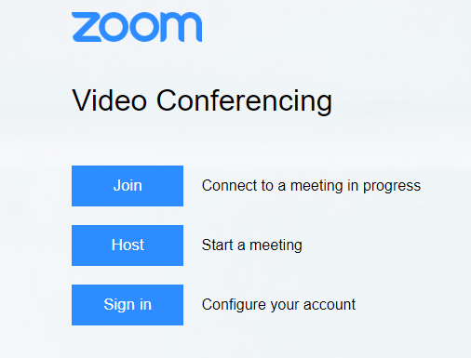

Joining a call
Type in the meeting ID number and click Join.

Hosting a call
Login using TSC email address and password

To Launch Zoom app using web browser
Click on “start from your browswer”

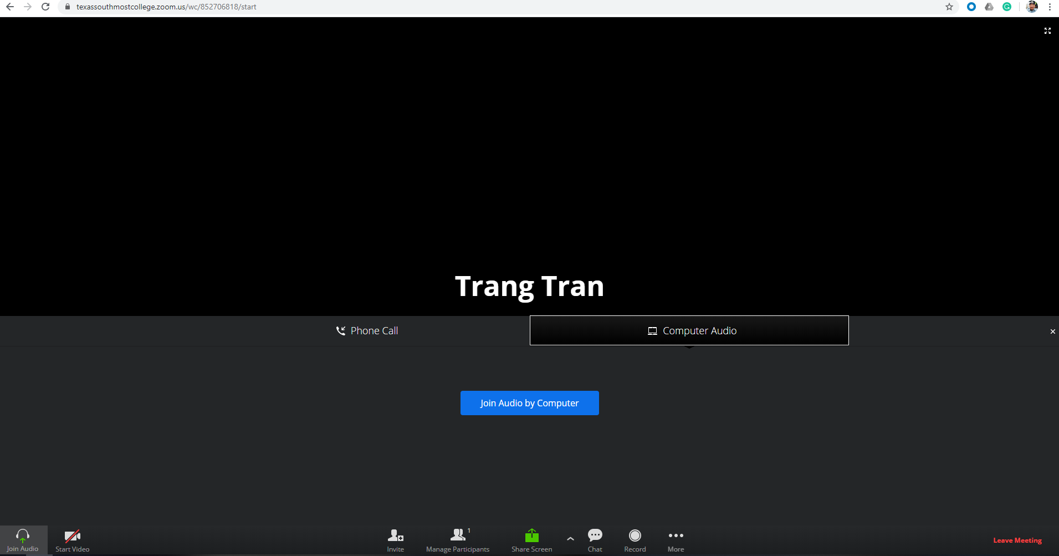

To Install Zoom client
Click on “Download Client” on the bottom of the page and follow installation instruction

To Launch Installed Zoom app on the computer
Click on “Open Zoom Meetings”
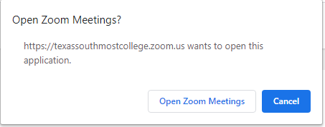
The local Zoom application will launch. User can manage a Zoom session for there.
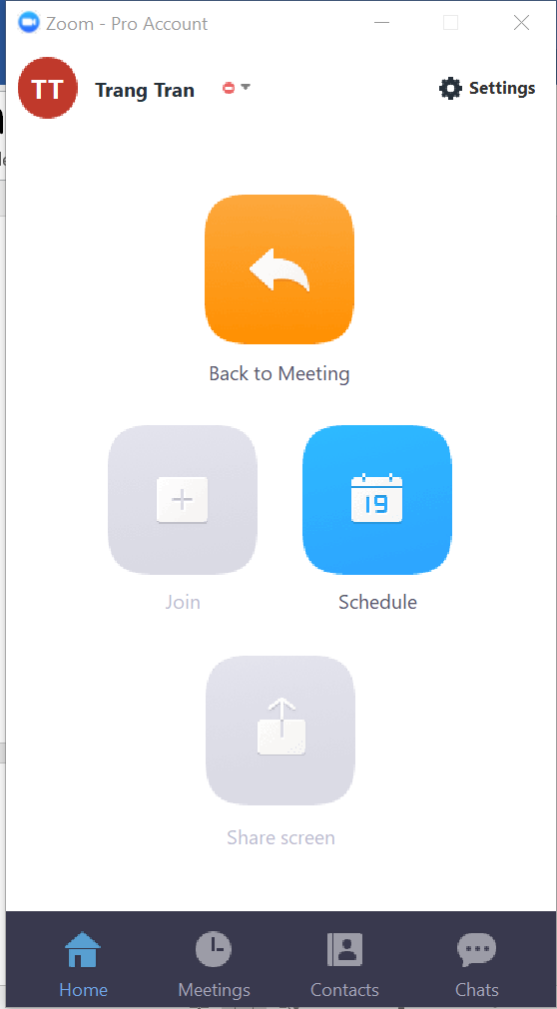
To Schedule a Call
Fill out the Topic and the Start date, time and duration, then click on “Schedule” button.
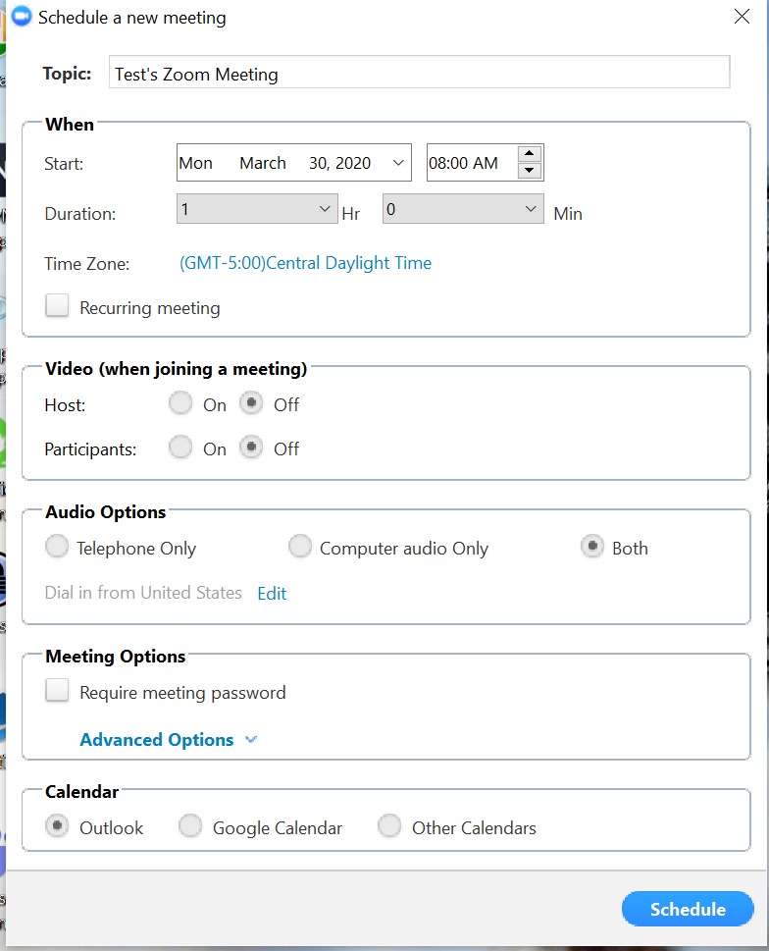
Add recipient(s) then click on send.
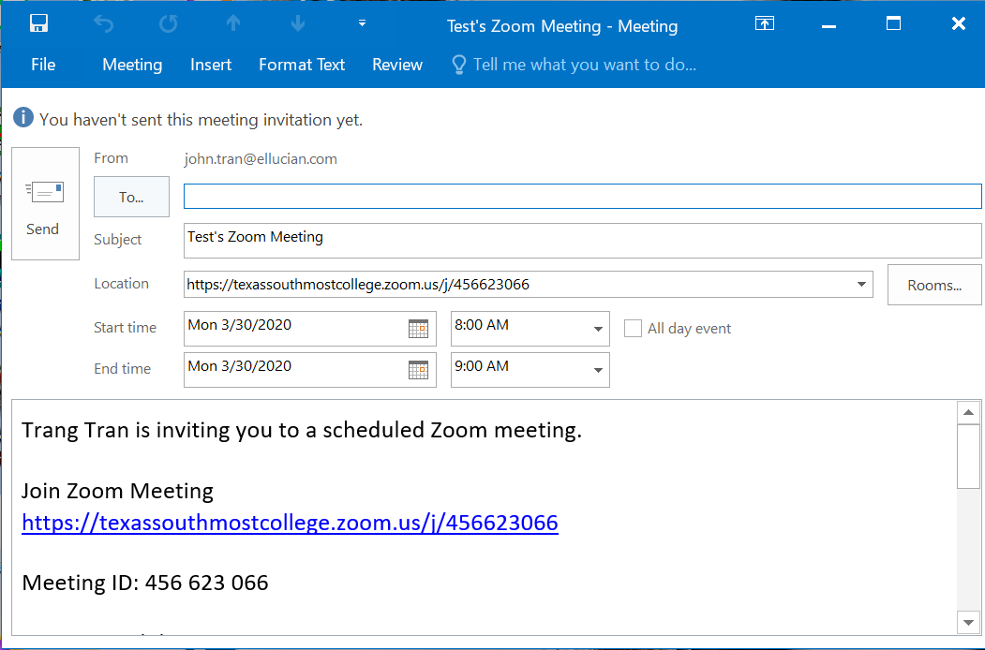

Training Materials:
Zoom Video Tutorials
https://support.zoom.us/hc/en-us/articles/206618765-Zoom-Video-Tutorials
Audio, Video, Sharing
https://support.zoom.us/hc/en-us/categories/201137166
Screen Sharing a PowerPoint Presentation
https://support.zoom.us/hc/en-us/articles/203395347-Screen-Sharing-a-PowerPoint-Presentation

