Email Signature – Texas Southmost College
Instructions

- Insert your information into the email signature on Page 2.
- Be sure not to change the formatting of the text:
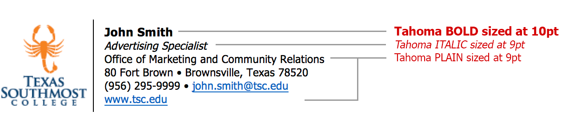
- It may be necessary to press RETURN after entering your email address in order for Microsoft Word to activate the hyperlink (for recipients to click on).
- Faculty and staff located at the Fort Brown Memorial campus should limit signature to 6 lines.
- Faculty and staff located at the ITEC Center should limit signature to 7 lines.
- Highlight and copy the email signature, making sure both columns are highlighted:
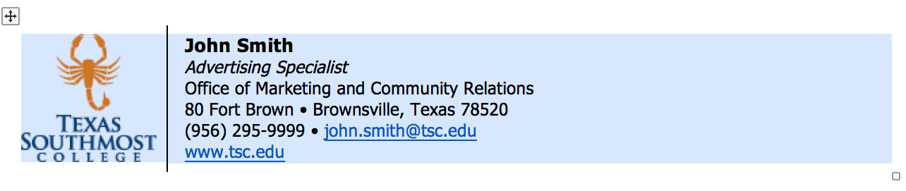
- In Microsoft Outlook (or preferred email client), create a new email signature and paste your copied text.

For detailed instructions on how to create and edit email signatures in Microsoft Outlook, please visit the Microsoft Support Page.

- Do NOT include room or office numbers.
- Do NOT use personal quotes, logos or icons in email signatures.
- Do NOT modify (stretch out, make larger) or change the logo in any way.
- Use ONLY the logo included in the email signature template.
- Academic credentials after your name should be limited to doctorate and master’s degrees. Use only the highest degree achieved.

Faculty/Staff located at Fort Brown Memorial Campus:

First and Last Name
Your Job Title
Division or Department
80 Fort Brown • Brownsville, Texas 78520
(956) 295-9999 • first.last@tsc.edu
www.tsc.edu

Faculty/Staff located at ITEC Center:

First and Last Name
Your Job Title
Division or Department
ITEC Center
301 Mexico Blvd. • Brownsville, Texas 78520
(956) 295-9999 • first.last@tsc.edu
www.tsc.edu

